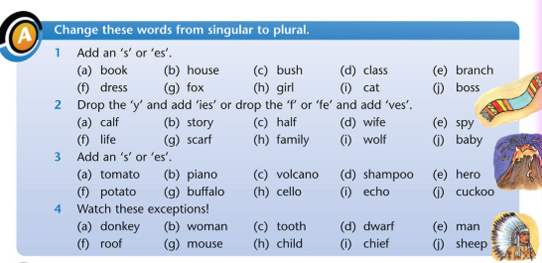

This is a revision exercise girls so make sure to put a bit of thought into it!
You are still making small mistakes with making words plural so this activity might help you to remember.

Do it into your copy

