Exploring Google Maps
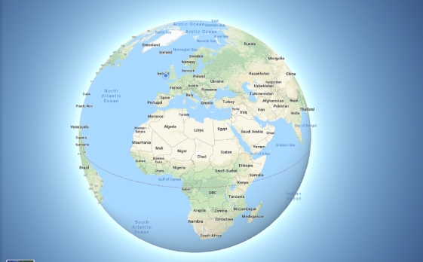
When you click on the link I provided, Google Maps should open on a satellite image of Ireland. Notice some of the icons on the map page. On the bottom left, you can click the little square that says ‘map’. This will change the kind of map you see. Click back and forth between the two options of ‘map’ and ‘satellite’.
What are the differences?
Which do you prefer?
On the bottom right corner you will find the ‘zoom in’ and ‘zoom out’ options. + and -.
Use these slowly to get a closer look at some of the areas on the map. Once you are comfortable and familiar with these, you can try some of the following:
- Find Tullamore on the map and compare how it looks as ‘map’ and as ‘satellite’.
- Can you find Killybegs (Donegal), Borris (Carlow), Adare (Limerick), Clones (Monaghan)? Can you tell anything about these areas using the map? (Is there a lake/river nearby? Are they on the coast or inland? Can you see mountains nearby?)
- Can you find 3 countries that are very far away from Ireland and 3 countries that are very close or are ‘neighbours’ of ours?
- Find the following countries are: New Zealand, Canada, Chile, Tanzania, Sri Lanka, Philippines, Argentina, Bulgaria, Norway, Morocco.

