Mindfulness for Children

Improves mental wellbeing

Helps to manage stress

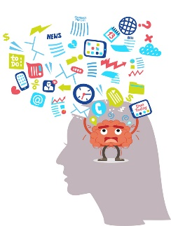

Increases feelings of calm

Helps alleviate anxiety

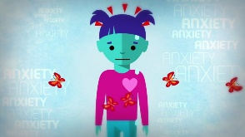

Mindfulness Games for Kids:
- Blowing bubbles
Have your child focus on taking in a deep, slow breath, and exhaling steadily to fill the bubble. Encourage them to pay close attention to the bubbles as they form, detach, and pop or float away.
- Windmills
Use the same tactics from blowing bubbles to encourage mindful attention on the windmill as it turns.
- Playing with balloons
Tell your kids that the aim of this game is to keep the balloon off the ground, but have them move slowly and gently.
- Texture bag
Place several small, interestingly shaped or textured objects in a bag. Have each child reach in and touch an object, one at a time, and describe what they are touching. Make sure they don’t take the object out of the bag, forcing them to use only their sense of touch to explore the object.
- Blindfolded taste tests
Use a blindfold for each child and have them experience eating a small food, like a blueberry or a raisin, as if it was their first time eating it.

