Odd Socks
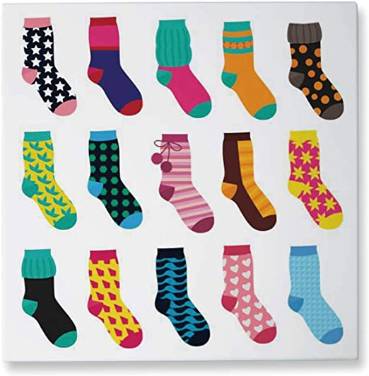
Writing
Where do the odd socks go? When a sock vanishes and is nowhere to be found…where has it gone? Did it run away? Has it gone to change jobs…maybe as a duster or a sock puppet? Maybe it just wanted some quiet time at the back of the washing machine for a few weeks?
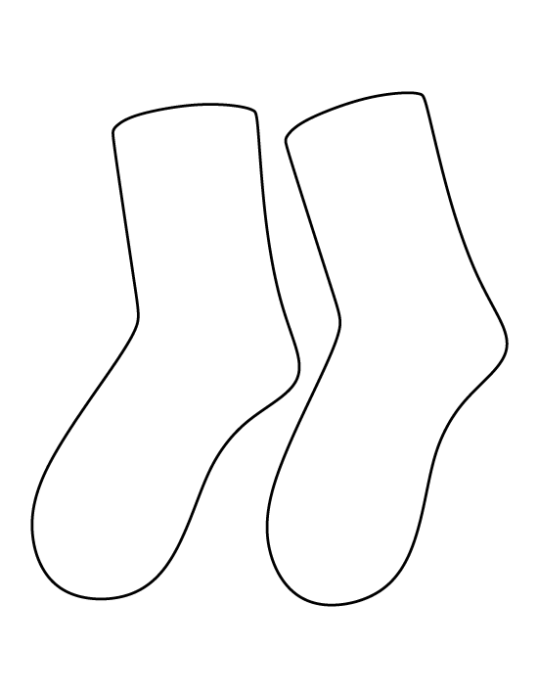
Use the template to design your own pair of FUNKY ODD SOCKS.
You can include any patterns or colours or characters you like.

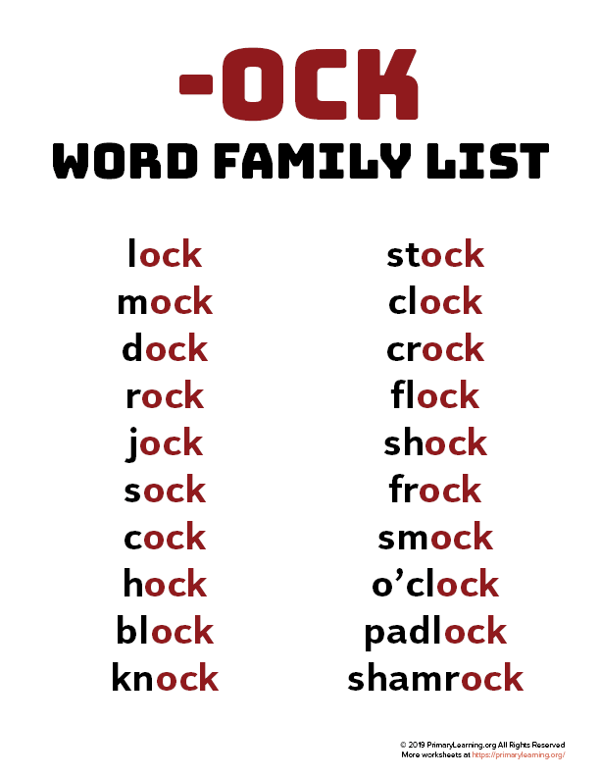
Can you think of any other words that contain
‘-ock’?
Can you use some of the above words in a sentence?

