Other curricular areas: Gaeilge, Science, Geography and Art
These activities might be interesting or fun for you and it helps our learning to make links with other subjects.

Gaeilge
Conas a déarfá 'hare' as Gaeilge? Cad is brí le focal seo?
Science/Geography
Write a report on the hare. The report should include facts and not opinions.
EXAMPLE: Fact: Hares don't dig burrows like rabbits do.
Opinion: Hares are really cute.
It should include information about the description, habitat and lifespan of the hare. It can also include information about different species.
As part of your Geography curriculum, why not create a map and colour it to show the different areas of the world where the different species of hare can be found.

Visual Arts
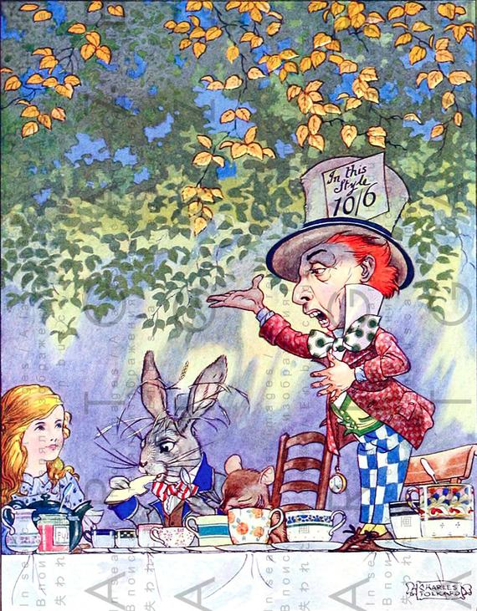

In the story of 'Alice in Wonderland', Alice has a tea-party with the March Hare, the Mad Hatter and Dormouse. Create a drawing of you having a tea party with 3 characters of your choice from any books you have read or movies you have seen.
Don't forget to include delicious treats!
I think I would choose Willy Wonka from 'Charlie and the Chocolate Factory', Dobby the house elf from 'Harry Potter' and Elsa from Frozen...wouldn't that be interesting!

