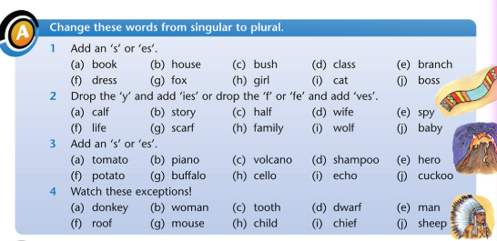
Books | Calves | tomatoes | donkeys
Houses | stories | pianos | women
Bushes | halves | volcanoes | teeth
classes | wives | shampoos | dwarves
Branches | spies | heroes | men
Dresses | lives | potatoes | rooves
Foxes | scarves | Buffalos/buffaloes | mice
Girls | families | cellos | children
Cats | wolves | echoes | Chiefs
bosses | babies | cuckoos | Sheep

