Prefix Challenge
Use a dictionary and see how many different words you can find with the following prefixes. Make sure that you spell them correctly!
auto….

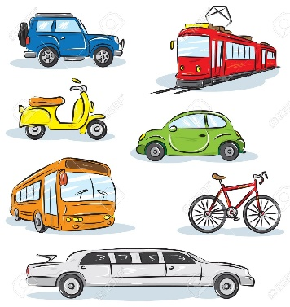
trans…

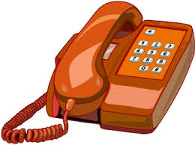
tele…

