States of Matter Activity Sheet
Section One: True or False
- All matter is made up of tiny particles called atoms ___________
- There are 1000 atoms in a full stop __________
- Matter can only be found on earth __________
- There are three main states of matter on earth ________
- Solids have a definite shape ________
- Atoms in a solid are loosely packed ________
- Atoms in a liquid have high energy _________
- Atoms in a gas have loads of space between them _______
- You can change through states by adding or removing energy _______
- When you take away energy from a liquid it freezes to become a solid _______

Section Two: Match each of the following with either A, B or C:
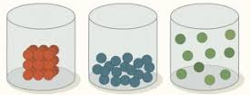
B
C
A

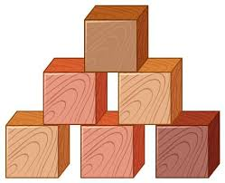 | 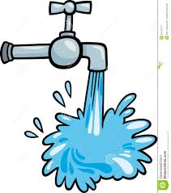  2. | 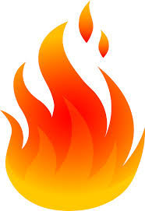  3.
4. | 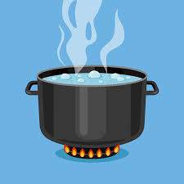  5. | 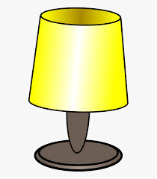  6.

