My
2020
Covid-19
Time Capsule
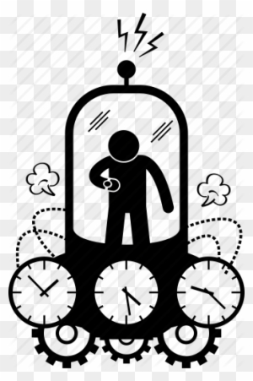
Name:___________

All About Me

Name:
Age
Friends:
Favourite Food:
Favourite Colour:
Favourite Sport:
Favourite Music:
Favourite Book:
3 words to describe myself:

How I’m Feeling
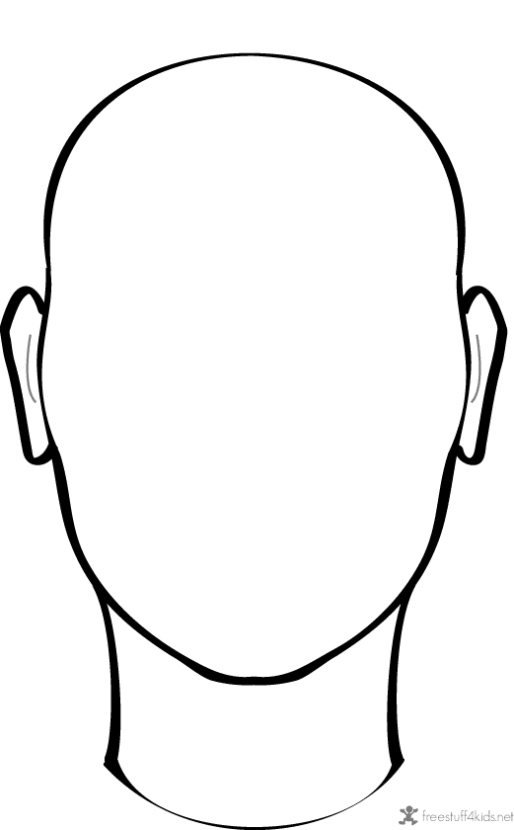
Draw your face
Living History
You are living through history right now!
Find some newspaper clippings to glue on this page

A Day in Your Life
How was today? Write a diary entry
_Date:_______________________________________________________________________________________________________________________________________________________________________________________________________________________________________________________________________________________________________________________________________________________________________________________________
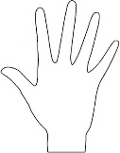 Your Handprints 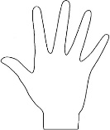
Print each hand on this page and the next…paint and press or draw around it.

A Letter to Myself
Dear…………………..
_______________________________________________________________________________________________________________________________________________________________________________________________________________________________________________________________________________________________________________________________________________________________________________________________________________________________________________________________________________________________________________________________________________________________________________________________________________________________________________________________________________________________________________________________________________________________________________________________________________________________________________________________________________________
Love …………………….
Parent’s Interview
What have been the top 3 moments from the experience?
What has been your biggest challenge?

What are you most thankful for?

What activities or hobbies have you most enjoyed doing?
Celebrations and Occasions
Write about anything special that happened (Easter/Birthdays) or draw/add a picture.

Mindfulness Colouring: Time Theme
