Maths/ Science – Making a rocket (Activity 1)
Our Aim
To help you design an experiment to test the effect of water temperature on the launch time of a film holder rocket.

Once the experiment has been conducted, you can carry out a number of maths related activities including measuring quantities and time, ordering and comparing responses and representing data.
Materials
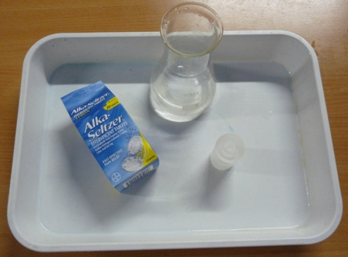

- Old camera film holders
- Effervescent tablets
- White tray or piece of paper for launch site if students are carrying out the activity in small groups
- Water: cold and hot (not boiling)
- Method for measuring liquid such as pipette, syringe or a medicine spoon
Caution should be applied as the rockets can take off with considerable force and noise. Consideration should be taken to conduct the experiment outside or in a room with a high ceiling. Never hold any part of your body over the rocket when it is about to launch. The launch may take several minutes to occur. If after 5 minutes the rocket does not launch, carefully pick it up and pop the lid off facing away from you.

Method:
You will need to design an experiment to test the effect of water temperature on the launch time of the rocket. The objective is for the quantity of water and tablet to remain constant between each rocket while the temperature varies.

Trigger questions:
- How will you measure the quantities of water? Do you have syringes or medicine spoons that can be used?
- How will you measure the quantity of the tablet? Are you going to cut it into quarters, and use roughly the same amount each time or will you weigh it out?
- How will you measure the reaction time? Do you have a stop watch or will you count the seconds manually?
- When should you start counting? Is it from the time the lid goes on the film holder or from the time it is put on the launch site?
- How will you measure the temperature? Will you use a rough guide of cold, warm (50\50 cold and hot) and hot? If you have access to thermometers, can you use exact temperature ranges such as 10, 20, 30, 40 degrees Celsius?

- You will have to draw a table for recording the results of the experiment such as the one below. Insert an additional column if using exact temperature ranges.

Water Temperature | Time (seconds)
Cold
Warm (50% cold + 50% hot)
Hot

Water Temperature | Time (seconds)
Cold | 30-40 seconds
Warm (50% cold + 50% hot) | 15-20 seconds
Hot | 5-15 seconds

- Prepare your first rocket using 5 mls of cold water. When you are ready, cut an effervescent tablet into quarters

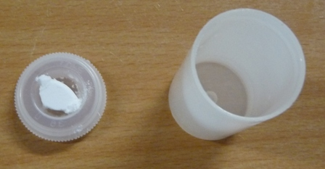

- Add the effervescent tablet to the water and secure the lid onto the top of the tube.
- Turn the rocket upside and place it on your launch site. You must record the time from activation to launch.

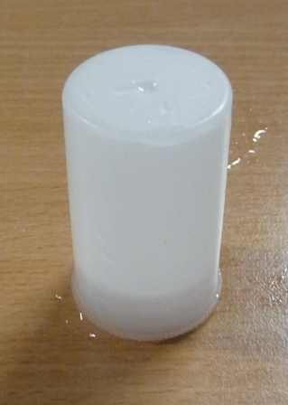

- Repeat the experiment using 50% cold water and 50% hot water (5 mls in total), and record the reaction time again.
- Finally, carry out your final experiment using 5 mls of hot (not boiling) water. Record reaction time.
- Order and compare the reaction times of your rockets. Which temperature produced the fastest reaction time?
- Display your results on a bar chart to compare your results.

What Happens?

- As the temperature of the water increases so should the reaction time of the rockets as the gas is released at a quicker rate within the film holder. Things that effect this result include:
- Accidently counting quicker as rockets are repeated and excitement grows.
- The lid of the holder not being secured properly and the rocket leaking
- The lid of the holder being too tight fitting and unable to pop off.

Additional Maths exercises
- Do you have access to a thermometer? If so, compare reaction time of rockets at 10, 20, 30, 40, 50 and 60 degrees Celsius.

Discussion Point
- Why do you think the rockets launch time decreased as the temperature increased?
- Is it important to keep the quantities of water and tablet constant while the water temperature is varied?
- What effect does varying water quantity or tablet quantity have on the rocket launch?

(Activity 2) Learning about Ocean Zones and Recording Ocean Temperatures.

The aim of the lesson is to help you identify and record positive and negative numbers on the number line i.e. -4,-3,-2,-1,0,1,2,3,4
- You will have to identify positive and negative numbers in the context of the number line and sea levels.

What you need to know
The ocean has layers and each layer ranges in temperature. The sunlight warms the top / surface of the ocean. However, the deeper into the ocean where it is darker (no sunlight) it gets colder and colder.

The sunlight zone is bathed in sunlight during the daytime. Its layer from the surface is about -200 meters deep. The temperature in the sunlight zone ranges (e.g. weather, surface currents etc) but on average are about 13-20°C.

The next level of the ocean is the twilight zone. It gets low levels of light during the day and is virtually dark. This layer of ocean ranges from -200 to about -1000 meters. Its temperatures range from 4- 20 °C.

The midnight zone is in utter blackness. It depths range from -1000 to -4000 metres. There is no “daytime” here at all. Midnight zone temperatures are about 4 °C.

The abyssal zone is at the bottom of the ocean at depths of -4,000 to -6,000 meters. The abyssal zone has temperatures around 2 °C to 3 °C.

The trench zone is at the deepest part of the ocean and is a narrow, elongate, vshaped cavity in the ocean floor. It is below -6000 to -11,000 metres. It can reach freezing temperatures of below 1 °C.

Active Learning:
- Draw a horizontal number line from +10 to -10. Include 0.

- Draw another number line and order these temperatures on the thermometer: 16°C 37°C -33°C -6°C -25°C 2°C 25°C 11°C -14°C

- Using the chart below complete the water depth of the zones of the ocean and place in the correct order: -4,000 to -6,000m -200 to -1000m -6000 to -11,000m 0 to -200m -1000 to -4000m

- Using the chart below complete the temperature of the depth of ocean zones using the temperatures listed below: 4°C, 13-20°C, 2-3° C, 4- 20 °C, 1 °C

- Note that the temperature decreases with the depth of the ocean.

Zone Name | Water depth | Water temperature
Sunlight Zone: is heated by the sun.

Twilight Zone: receives only a faint amount of light from the sun.

Midnight zone: the sunlight does not reach this zone

Abyssal zone: the water is in absolute darkness

The Trenches: the bottom of the deepest parts of the ocean. These areas are mostly found in deep water trenches and canyons

Environmental Protection
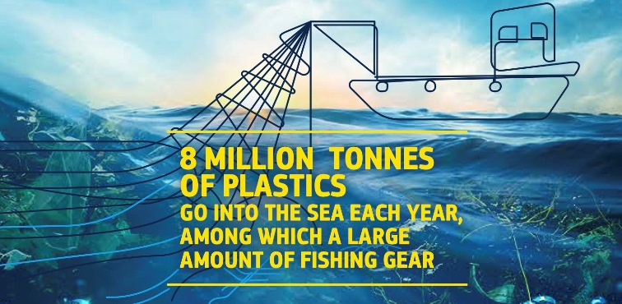
- Just so you have an idea of how much palatic this is, a car would weigh about 1 tonne. This is roughly the same as the weight of 8 million cars being dumped into the ocean each year.
- There are currently 5 trillion pieces of plastic waste in the world’s oceans
- People across the world eat about 5 grammes of plastic each week (about the weight of a credit card)
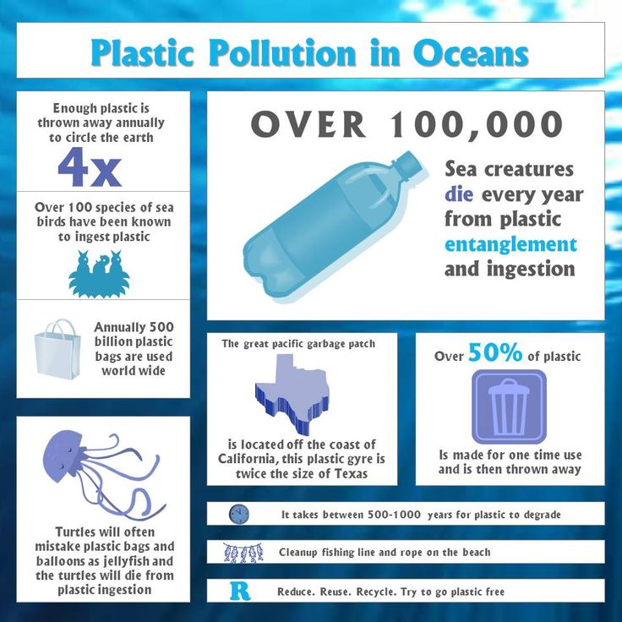

Activity
I would like you to design a poster highlighting the importance of severly reducing the amount of plastics that end up in our oceans. Include a minimum of 10 facts (similar to the facts above) on your poster.

English
Poetry This week we are continuing with sonnets. Sticking with our theme for this week “Under The Sea”, below is a sonnet I would like you to read called “Little Mirmaid Sonnet”

The Little Mermaid lives under the sea
She lived in Atlantic with her father
Ariel really wanted to be free
Ursula gave Ariel an offer
Ariel gave her Mermaid tale for feet
She gave her lovely voice to Ursula
She immediately started to fleet
Ursula created a formula
She had to get a kiss from lover boy
She only has 3 days to get the kiss
Ariel got the kiss and was in joy
The two would be able to live in bliss
Even though she broke a great tradition
However her father gave permission

Activities
- Write a sonnet of your own based on our theme “Under the sea”
- Remember the rhyming scheme for an English Sonnet is:
abab
cdcd
efef
gg
This means that the first and third lines of each four line stanza rhyme and the second and fourth lines of each four line stanza rhyme. The two lines of the closing stanza should rhyme as well. Each line of the stanza should have no more and no less than ten syllables.

- Last week we focused on formal and informal letter writing. This week we will continue with letter writing with focus on “Warning letters” To tie in with our theme “Under the Sea” I would like you to write a letter to the people of the world warning them about the devestating effects of allowing plastics to continue ending up in our seas and oceans. This will be a formal letter encouraging the poeple of the world to care for their seas and oceans. Your letter should include facts aboout the damage that has already been done as well as possible solutions.

- Please remember to continue with your daily diary.
- Make sure that you are continuing to read every day.

Gaeilge
- Below is our dán (poem) for this week called “An Bóthar Chun Trá” I would like you to translate this poem the best you can and then draw a picture of what this poem brings to your imagination :)

An Bóthar Chun Na Trá (The Road to the beach)
Tá an ghrian gheal sa spéir
Is tá na páistí go léir
Ar an mbóthar chun na trá.
Beidh spórt acu is scléip
Ag rith agus ag léim
San fharraige cois trá.
Is orthu a bheidh ríméad
Ag líonadh na mbuicéad
Is ag déanamh na gcaisleán
Tá an ghrian gheal sa spéir
Is nach aoibhinn dóibh go léir
Ar an mbóthar chun na trá.

- The list of words below are all related to out theme “Under The Sea” I would like you to put each of these words into a two line Irish sentence. Remember that in Gaeilge we usually start a sentence with a verb or a timing
e.g. “Inné, chuaigh me go dtí an trá le mo chlann”

- Ochtapas 2) bráthair 3) portán 4) iasc 5) turtar 6) feamainn 7) sliogán 8) capall mara 9) siorc 10) míol mór 11) fomhuireán 12) tumadóir 13) ancaire 14) scuid

Best of luck with this week’s work and email me if you are having any difficulties. I hope you are all exercising each day, eating healthy food and enjoying the sunshine ;)
Take care,
M. Murphy

