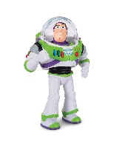Who Am I?
Why not print or write the names below on some paper, cut them out and fold them up so that no one can see.
One person takes a piece of paper. All other people playing the game (it can be one other person, or more) must ask questions to figure out who it is. Only Yes/No responses are allowed!
Some questions to help narrow it down might be:
- Are you female? Are you male?
- Are you a human? Are you an animal? Are you a magical creature?
- Have you been in a movie in the last year? A book? A music video? A TV programme?
- Are you the good character/hero?
- Do you sing well?
- Do you make people laugh? Are other characters afraid of you?
- Are you a character in a book/nursery rhyme?

If you like you can use these ideas/some of these ideas and add your own:
Minnie Mouse | Ariel the Little Mermaid | Simon Cowell | Maleficent
Billie Eilish | Joe Wicks | Buzz Lightyear | Katie Taylor
Humpty Dumpty | Lady Gaga | Olaf (Frozen) | Hermione Granger
Tinkerbell | Michael D Higgins | Scooby Doo | Joe Canning
Willie Wonka | Leo Varadkar | Peppa Pig | Santa Claus

